Page Turners Book Discussion Group
Schedule and Title List 2022
Fourth Wednesday of the month
@ 2:00 p.m.

January 26, 2022
In Five Years by Rebecca Serle
c. 2021; 255 pages

February 23, 2022
Authenticity Project by Clare Pooley
c. 2020; 357 pages

March 23, 2022
Invisible Life of Addie Larue by Victoria Schwab
c. 2020; 444 pages

April 27, 2022
Anxious People by Fredrick Backman
c. 2020; 341 pages
May 25, 2022
Seven Husbands of Evelyn Hugo by Taylor Jenkins Reed
c. 2017; 389 pages

June 22, 2022
Lost Apothecary by Sarah Penner
c. 2021; 301 pages

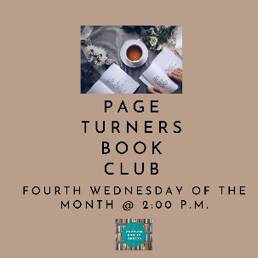

July 27, 2022
Long Petal of the Sea by Isabel Allende
c. 2020; 318 pages

August 24, 2022
The Only Woman in the Room by Marie Benedict
c. 2019; 254 pages
September 28, 2022
The Midnight Library by Matt Haig
c. 2020; 288 pages

October 26, 2022
Dark Matter by Blake Crouch
c. 2016; 342 pages
November 23, 2022
NO MEETING
HAPPY THANKSGIVING!

December 28, 2022
MEETING?

