Non-Fiction Book Discussion Group
Titles & Schedule for 2022
Third Monday of the Month @ 7:00 p.m.
*unless there is a Monday holiday

January 24, 2022
Braving the Wilderness by Brene Brown
c. 2017; 194 pages
February 28, 2022
Elizabeth & Margaret: the intimate world of the Windsor sisters
by Andrew Morton
c. 2021; 362 pages
March 28, 2022
Underground Girls of Kabul by Jenny Nordberg
c.2014; 350 pages

April 25, 2022
Empire of Pain: the secret history of the Sackler Family by Patrick Radden Keefe
c. 2021; 535 pages
May 16, 2022
Brain on Fire by Susannah Cahalan
c. 2012; 264 pages

June 27, 2022
In the Garden of Beasts by Erik Larson
c. 2011; 448 pages

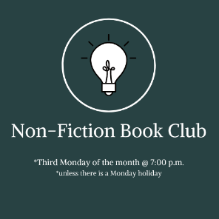

July 18, 2022
Boys in the Boat by Daniel Brown
c. 2013; 404 pages

August 15, 2022
Elephant Company: the inspiring story of an unlikely hero and the animals who helped him save lives in WWII by Vicki Croke
c. 2014; 343 pages
September 19, 2022
Omnivore’s Dilemma by Michael Pollan
c. 2006; 450 pages
October 17, 2022
I’ll Be Gone in the Dark by Michelle McNamara
c. 2018; 328 pages
November 21, 2022
Mayflower: A Story of courage, community and war by Nathaniel Philbrick
c. 2006; 461 pages

December 19, 2022
Have a Little Faith by Mitch Albom
c. 2009; 254 pages

