Mobile Printing at the Agawam Library
How to Print from a portable device (phone, tablet, laptop computer, etc):
- Visit https://www.printeron.net/aga/agawam.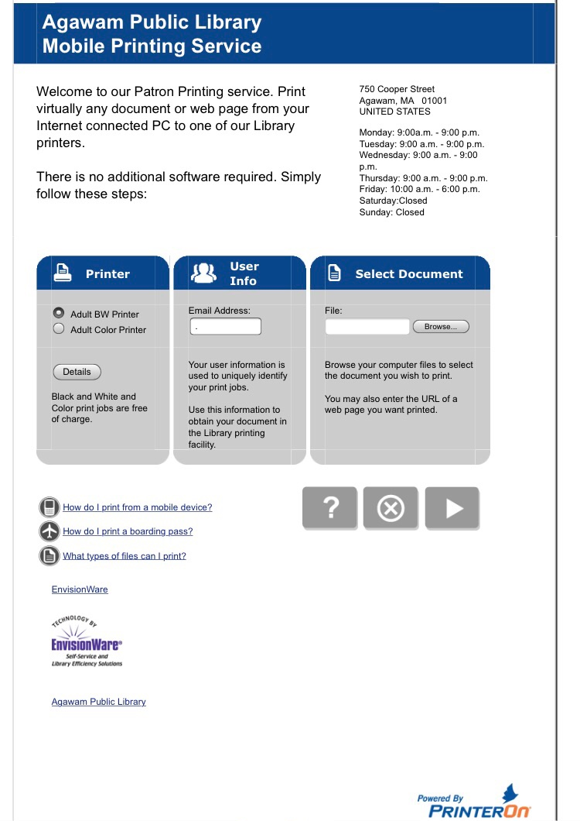

- Under Printer select either the Adult BW (Black & White) or Adult Color Printer
- Under User Info enter your email address.
- Under Select Document, tap the Browse button and select the file or photo you wish to print.
- Tap the grey arrow icon in the lower right hand corner. (It may take a few moments to load.)
- The screen will change & say Approve print job. Please tap the green printer icon in lower right hand corner of screen to approve your print request.

- Your document request will take a few moments to process, then your screen should refresh by itself and look like this:

- You do not need to take down the job reference #, print jobs are listed under your email address and can be picked up at the library’s Print Release Station in the Reference Department or by asking the Reference Desk staff to release the print job for you.

How to print emails:

- Forward the email to either agawam-bw@printspots.com for black & white
or agawam-color@printspots.com for color.
- Please visit or call the Library’s Reference Desk in order to have your job printed. Reminder, the staff will need to know that email address in order to know which print job is yours.
How to print using the App:
(Downloading the App is a great idea if you will be using our mobile print service often):
- Download the free App from your App store.
- Open the PrinterOn App
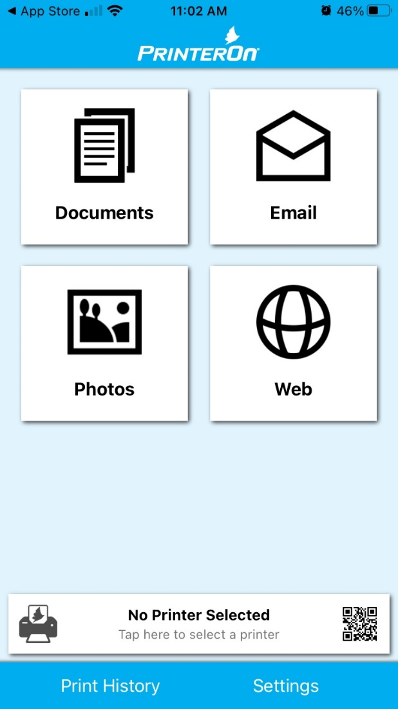
- At the bottom of the screen, it will say No Printer Selected initially. Tap the No Printer Selected bar & it will bring up a mostly blank screen, which should say Select Printer.
- At the bottom right hand of the screen is the Search button, tap it and type in Agawam.
- Two printer choices should then appear Adult Color Printer & Adult BW Printer. Please select one by tapping on it.
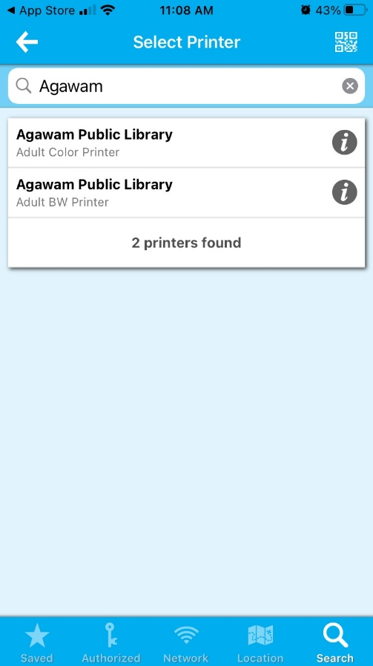
- The next screen should have 4 tap-able buttons viewable on your screen: Documents, Email, Photos & Web. The 1st three will allow you to search the Documents, Email or Photos section of your device. The fourth will allow you to print a web page.
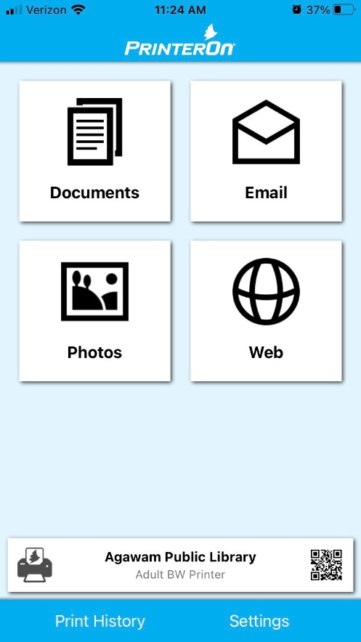
- When the file you want to print is selected, please tap the green Print button in the lower right hand corner of the screen.
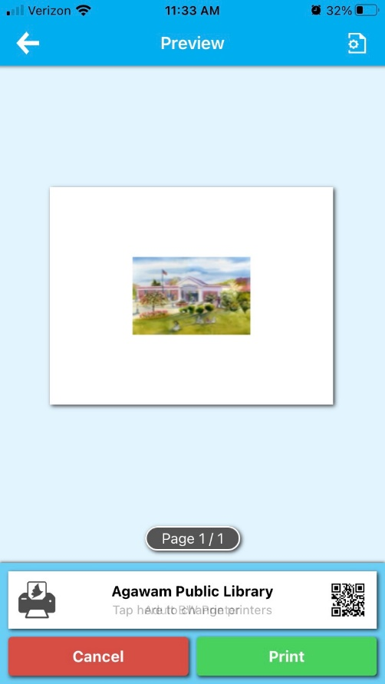

- Then enter an email address and tap the check mark located in the upper right hand corner of the screen to finalize your print request.
- Then you will receive an alert message on your screen stating Job Started, and then shortly afterward another in green stating then Job Success.
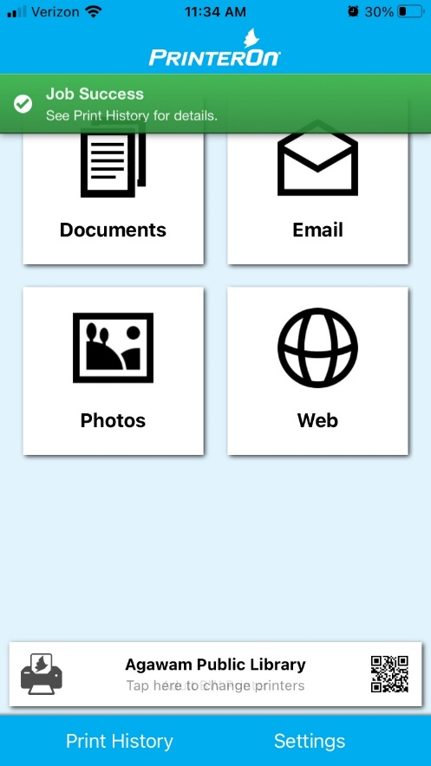
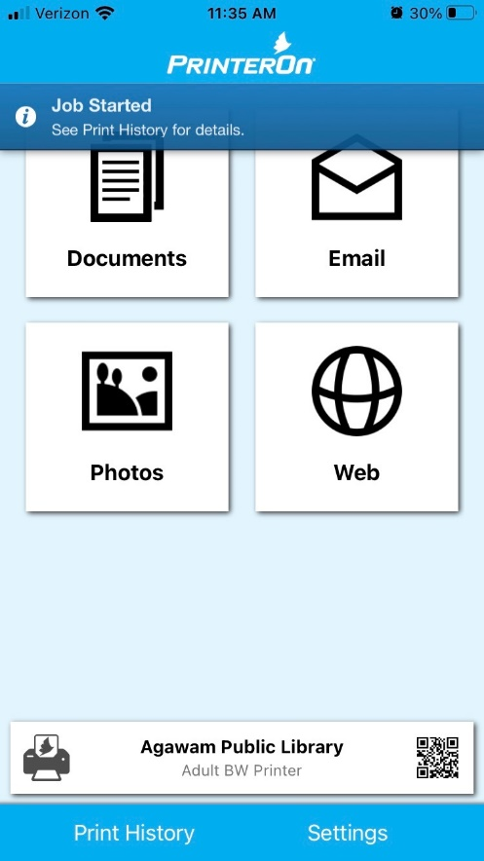
- Please visit or call the Library’s Reference Desk in order to have your job printed. Reminder, the staff will need to know that email address in order to know which print job is yours.

Note: All pictures of the screens were taken from an iPhone, screens may be slightly different on other devices.

March 2021

